<%@ page language="java" contentType="text/html; charset=ISO-8859-1"
pageEncoding="ISO-8859-1"%>
<!DOCTYPE html PUBLIC "-//W3C//DTD HTML 4.01 Transitional//EN" "http://www.w3.org/TR/html4/loose.dtd">
<html>
<head>
<meta http-equiv="Content-Type" content="text/html; charset=ISO-8859-1">
<title>Insert title here</title>
</head>
<body>
<!-- <script type="text/javascript">//There are 50 different type of script language are we need to
tell explicitly to the browser that i am using JavaScript by passing type="text/javascript"
</script> -->

<script type="text/javascript">
document.write("Hello");
</script>
</body>
</html>

2.What if i have older browser they dont understand what JS is and when they come across the JS code they simpli print the whole code to Overcome that problem we use

<script type="text/javascript">
<!--
document.write("Hello");
//-->
</script>
But we are using new browser so we dont need this Paranthesis

3.Comments And Statements
<script type="text/javascript">
// Comments goes Here Single Line comment

/* Multiline Comment
will goes here
ok
*/
</script>

Staements Are
<script type="text/javascript">
document.write("I love India");//Same as SYSO
document.write(" I love Russia too");
</script>

4. Variables
<script type="text/javascript">
var x = 25;
document.write(x);
// way to declare a variable in javascript its must be start with letter or underscore not with any regex like $,% or Number
</script>

5. Variables for TEXT
<script type="text/javascript">
var x = "ABC,"Ok I Love India"";
document.write(x);
// There are two different String Before OK,JS not be able to understand that its a part of my TEXT in order to tell that....
We need to add somethng called SKATE Character

var x = "ABC,\"Ok I Love India\"";
document.write(x);

To Store a boolean value we use
var x = false;

To Store a null value we use
var x = null; and this is completly different then zero
</script>

6. Using Variable with String of Text
<script type="text/javascript">

var x= "Shahnawaz";
var y = 23;
document.write("My name is " + x + " My age is "+y);
</script>

7. Functions or Methods
<script type="text/javascript">
function funky(){ //Creating a functions
alert("ouch!....");//Logics
}
funky();//Calling a functions

Function calling with OnClick

<script type="text/javascript">
function funky(){
alert("ouch!....");
}
</script>
<form action="">
<input type="button" value="Click Me" onclick="funky()">
</form>
</script>

7. Using parameter with Functions or Methods
<script type="text/javascript">
function funky(x){
alert("i am with " + x);
}
funky("Sam");
funky("ABC");

</script>

8. Using Function with Multiple Parameter
<script type="text/javascript">
function funky(one,two){
document.write(one + " is better than " + two + "<br>");
}
funky("I am","You All");
funky("A","B");
</script>

9.The return statements
<script type="text/javascript">
function toEasy(a,b){
var c = a+b;
return c;
}
document.write(toEasy(3,9));
</script>

10.Calling Function to Another Functions
<script type="text/javascript">
function first(){
document.write("I am First");
}
function second(){
document.write("I am Second");
}
function start(){
document.write("I am First");
first();
second();
}
start();
</script>

11.Global and Local Variables
same as Java Instance and Local variable
show any example

12.Math Operators
Same as Java Arithmetic Operator
Increment and Decrement are also there show that Example

13.AssignMent Operators
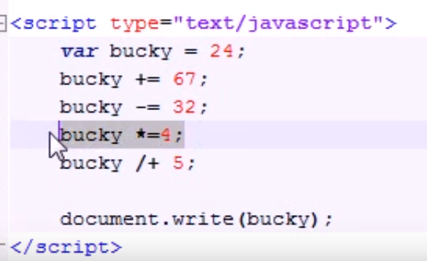

14. If Statement
Take Any Example Of Java if statemtn

15.If Else Statement
Take Any Example Of Java if else statemtn

16.Nesting and Fridays
Take Any Example Of Java Nested if else statemtn

17.Complex Conditions
Show about AND n Or operator sign for AND is && n for OR is || same as Java

18.switch Same as Java

19.for
for(x=0;x<10;x++){
document.write("A");
}

20.while Loop
var x = 1;
while(x<10){
document.write("X");
x++;
}
Example of confirm() in javascript
- <script type="text/javascript">
- function msg(){
- var v= confirm("Are u sure?");
- if(v==true){
- alert("ok");
- }
- else{
- alert("cancel");
- }

- }
- </script>

- <input type="button" value="delete record" onclick="msg()"/>

Example of prompt() in javascript
It displays prompt dialog box for input. It has message and textfield.
- <script type="text/javascript">
- function msg(){
- var v= prompt("Who are you?");
- alert("I am "+v);

- }
- </script>

- <input type="button" value="click" onclick="msg()"/>

Example of open() in javascript
- <script type="text/javascript">
- function msg(){
- open("http://www.javatpoint.com");
- }
- </script>
- <input type="button" value="javatpoint" onclick="msg()"/>

Example of setTimeout() in javascript
It performs its task after the given milliseconds.
- <script type="text/javascript">
- function msg(){
- setTimeout(
- function(){
- alert("Welcome to Javatpoint after 2 seconds")
- },2000);

- }
- </script>

- <input type="button" value="click" onclick="msg()"/>

Document Object Model
The document object represents the whole html document.
When html document is loaded in the browser, it becomes a document object. It is the root element that represents the html document.
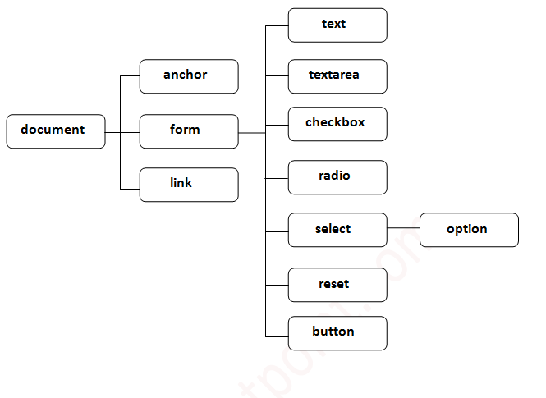
Methods of document object
Method | Description
write("string") | writes the given string on the doucment.
writeln("string") | writes the given string on the doucment with newline character at the end.
getElementById() | returns the element having the given id value.
getElementsByName() | returns all the elements having the given name value.
getElementsByTagName() | returns all the elements having the given tag name.
getElementsByClassName() | returns all the elements having the given class name.

- <script type="text/javascript">
- function printvalue(){
- var name=document.form1.name.value;
- alert("Welcome: "+name);
- }
- </script>

- <form name="form1">
- Enter Name:<input type="text" name="name"/>
- <input type="button" onclick="printvalue()" value="print name"/>
- </form>

Example of document.getElementsByName() method
- <script type="text/javascript">
- function totalelements()
- {
- var allgenders=document.getElementsByName("gender");
- alert("Total Genders:"+allgenders.length);
- }
- </script>
- <form>
- Male:<input type="radio" name="gender" value="male">
- Female:<input type="radio" name="gender" value="female">

- <input type="button" onclick="totalelements()" value="Total Genders">
- </form>

document.getElementsByTagName() method
The document.getElementsByTagName() method returns all the element of specified tag name.
- <script type="text/javascript">
- function countpara(){
- var totalpara=document.getElementsByTagName("p");
- alert("total p tags are: "+totalpara.length);

- }
- </script>
- <p>This is a pragraph</p>
- <p>Here we are going to count total number of paragraphs by getElementByTagName() method.</p>
- <p>Let's see the simple example</p>
- <button onclick="countpara()">count paragraph</button>

Note: Output of the given examples may differ on this page because it will count the total number of para , total number of h2 and total number of h3 tags used in this document.

Javascript – innerHTML
The innerHTML property can be used to write the dynamic html on the html document

- <script type="text/javascript" >
- function showcommentform() {
- var data="Name:<input type='text' name='name'><br>Comment:<textarea rows='5' cols='80'></textarea><br><input type='submit' value='comment'>";

- document.getElementById('mylocation').innerHTML=data;
- }

- </script>
- <form name="myForm">
- <input type="button" value="comment" onclick="showcommentform()">
- <div id="mylocation"></div>
- </form>
Javascript – innerText
- <script type="text/javascript" >
- function validate() {
- var msg;
- if(document.myForm.userPass.value.length>5){
- msg="good";
- }
- else{
- msg="poor";
- }
- document.getElementById('mylocation').innerText=msg;
- }

- </script>
- <form name="myForm">
- <input type="password" value="" name="userPass" onkeyup="validate()">
- Strength:<span id="mylocation">no strength</span>
- </form>
JavaScript Form Validation
- <script>
- function validateform(){
- var name=document.myform.name.value;
- var password=document.myform.password.value;

- if (name==null || name==""){
- alert("Name can't be blank");
- return false;
- }else if(password.length<6){
- alert("Password must be at least 6 characters long.");
- return false;
- }
- }
- </script>
- <body>
- <form name="myform" method="post" action="abc.jsp" onsubmit="return validateform()" >
- Name: <input type="text" name="name"><br/>
- Password: <input type="password" name="password"><br/>
- <input type="submit" value="register">
- </form>

JavaScript Retype Password Validation
- <script type="text/javascript">
- function matchpass(){
- var firstpassword=document.f1.password.value;
- var secondpassword=document.f1.password2.value;

- if(firstpassword==secondpassword){
- return true;
- }
- else{
- alert("password must be same!");
- return false;
- }
- }
- </script>

- <form name="f1" action="register.jsp" onsubmit="return matchpass()">
- Password:<input type="password" name="password" /><br/>
- Re-enter Password:<input type="password" name="password2"/><br/>
- <input type="submit">
- </form>

JavaScript Number Validation
- <script>
- function validate(){
- var num=document.myform.num.value;
- if (isNaN(num)){
- document.getElementById("numloc").innerHTML="Enter Numeric value only";
- return false;
- }else{
- return true;
- }
- }
- </script>
- <form name="myform" onsubmit="return validate()" >
- Number: <input type="text" name="num"><span id="numloc"></span><br/>
- <input type="submit" value="submit">
- </form>

JavaScript email validation

We can validate the email by the help of JavaScript.
There are many criteria that need to be follow to validate the email id such as:
- email id must contain the @ and . character
- There must be at least one character before and after the @.
- There must be at least two characters after . (dot).
- <script>
- function validateemail()
- {
- var x=document.myform.email.value;
- var atposition=x.indexOf("@");
- var dotposition=x.lastIndexOf(".");
- if (atposition<1 || dotposition<atposition+2 || dotposition+2>=x.length){
- alert("Please enter a valid e-mail address \n atpostion:"+atposition+"\n dotposition:"+dotposition);
- return false;
- }
- }
- </script>
- <body>
- <form name="myform" method="post" action="#" onsubmit="return validateemail();">
- Email: <input type="text" name="email"><br/>

- <input type="submit" value="register">
- </form>
JavaScript Date Object
The JavaScript date object can be used to get year, month and day. You can display a timer on the webpage by the help of JavaScript date object
Constructor
- Date()
- Date(milliseconds)
- Date(dateString)
- Date(year, month, day, hours, minutes, seconds, milliseconds)

JavaScript Date Example
- Current Date and Time: <span id="txt"></span>
- <script>
- var today=new Date();
- document.getElementById('txt').innerHTML=today;
- </script>

JavaScript Current Time Example
- Current Time: <span id="txt"></span>
- <script>
- var today=new Date();
- var h=today.getHours();
- var m=today.getMinutes();
- var s=today.getSeconds();
- document.getElementById('txt').innerHTML=h+":"+m+":"+s;
- </script>

JavaScript Digital Clock Example
- Current Time: <span id="txt"></span>
- <script>
- window.onload=function(){getTime();}
- function getTime(){
- var today=new Date();
- var h=today.getHours();
- var m=today.getMinutes();
- var s=today.getSeconds();
- // add a zero in front of numbers<10
- m=checkTime(m);
- s=checkTime(s);
- document.getElementById('txt').innerHTML=h+":"+m+":"+s;
- setTimeout(function(){getTime()},1000);
- }
- //setInterval("getTime()",1000);//another way
- function checkTime(i){
- if (i<10){
- i="0" + i;
- }
- return i;
- }
- </script>

JavaScript ReverSe Number Example
<!DOCTYPE html>
<html>
<head>
<meta charset="ISO-8859-1">
<title>First Program</title>
<script type="text/javascript">

function funky() {
var x = +document.getElementById("A").value;
var rem = 0,rev = 0;

while(x!=0){
rem = x % 10;
rev = rev * 10 + rem;
x = parseInt(x / 10);
}
document.write(rev);
}
</script>

</head>
<body>
<form action="" onsubmit="funky()">
<input type="text" id="A">
<input type="submit">
</form>
</body>
</html>

http://www.dineshkrish.com/javascript/

